MDR and AVHE Access Procedures

The SAS Computing Environment (SCE) provides authorized individuals with access and query capability to specified Military Health System (MHS) Data Repository (MDR) data sets. The SCE is for experienced healthcare analysts who are enterprise-level power users possessing a thorough knowledge of SAS and existing MHS data sets.
Access to the SCE requires MDR data access approval. For instructions on how to apply for MDR access or how to modify your MDR access, see Section 1 of this document.
The SAS Computing Environment (SCE), located within the MHS Information Platform (MIP) AWS GovCloud, must be accessed through the Application Virtualization Hosting Environment (AVHE). AVHE is a DHA-hosted internet browser-based virtual desktop environment which, once connected, will allow an authorized user to use PuTTY, WinSCP, and/or SAS Enterprise Guide to connect to the MDR SCE. See Section 2 of this document for instructions on requesting AVHE access.
SCENARIOS:

- If you are a new user and have no MDR SCE or AVHE access, complete and submit both the MDR AARF and AVHE required documents (follow instructions in BOTH Section 1 and 2).

- If you already have both MDR SCE and AVHE access, you are all set and do not need to do anything.

- If you have both MDR SCE and AVHE access but need to request access to additional MDR data types, complete and submit the MDR AARF (see instructions contained in Section 1).

- If you have both MDR SCE and AVHE access but begn working on an additional contract which requires MDR access, complete and submit the MDR AARF to ensure access under the additional contract is documented and approved (see instructions contained in Section 1).

- If you have an MDR SCE account but no AVHE access, complete and submit for AVHE access only (see instructions contained in Section 2).

- If you have AVHE access but no MDR SCE access, complete and submit both the MDR AARF and AVHE documents ensuring the AVHE SAAR is marked as a MODIFICATION.

Table of Contents
Section 1: Instructions for requesting a SCE account to access MDR data 3
Requirements for MDR SCE access: 3
Follow these instructions to modify or apply for a new MDR SCE account: 3
Section 2: Instructions for requesting AVHE access to the MDR SCE 5
Requirements for AVHE access: 5
Follow these instructions to apply for AVHE access to the MDR SCE: 5
Section 3: Instructions for submitting your MDR SCE or AVHE forms for processing 9

Figure A: Required documents for AVHE access 6
Figure B: Part II of MIP SAAR 7
Figure C: How to find PIV number and enter it on the MIP SAAR 8
Figure D: MIP SAAR Digital Signature Block 32 8
Figure E: MIP MUG Site 9
Figure F: Click on New Item 9
Figure G: Save SAAR Package 11

Section 1: Instructions for requesting a SCE account to access MDR data

Requirements for MDR SCE access:
- CAC card
- HIPAA & Privacy Act Training Certificate – completed within the past year and must not be within 2 months of expiration
- Cyber Awareness Training Certificate – completed within the past year and must not be within 2 months of expiration
- AVHE access or application for access submitted

Follow these instructions to modify or apply for a new MDR SCE account:
- Log on to the MIP MUG site at https://carepoint.health.mil/sites/MIP/mugteam/SitePages/EIDS%20SAAR.aspx
Note: You will need your CAC card to logon

- Click on MDR AARF, which is in the table on the right side on the screen as shown in Figure A and download it to your desktop.

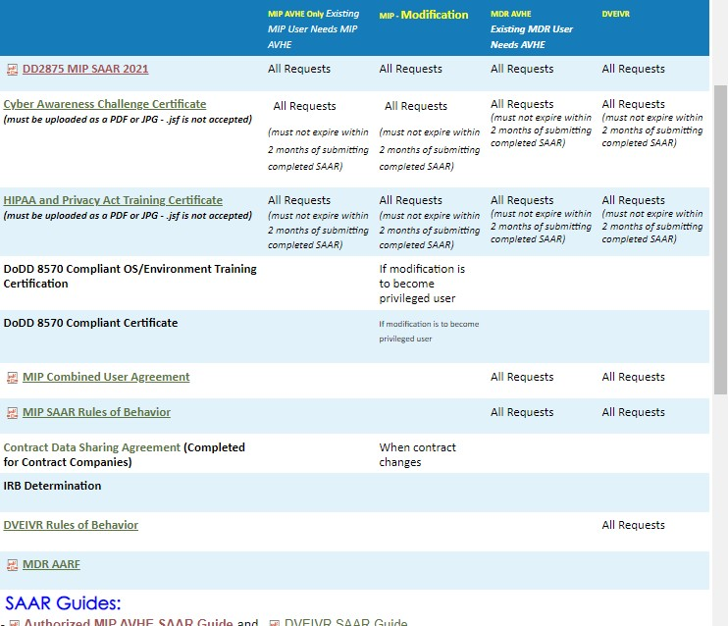
Figure A: Screen shot of MUG SAAR site showing location of link for MDR AARF
- Complete the MDR AARF. Date, sign, and save the document for upload to the MUG during a later step. For the sections identified below, complete as directed.
Note: Open the documents in Adobe Acrobat Reader to enable digital signing.
  - 2. Data Requested: Complete as requested. For information on data contained in the MDR please see the MDR Data Dictionary which can be found at: MDR, M2, ICDs Functional References and Specifications | Health.mil

- Proceed to Section 3 for instructions on submitting your documents to the MUG site for processing.

Section 2: Instructions for requesting AVHE access to the MDR SCE

Requirements for AVHE access:
- CAC card
- A “.mil” email address
- 16-digit PIV on your CAC
- Citrix Workspace (Receiver) – Will automatically download and install to your workstation when connecting to AVHE
- HIPAA & Privacy Act Training Certificate – completed within the past year and must not be within 2 months of expiration
- Cyber Awareness Training Certificate – completed within the past year and must not be within 2 months of expiration
- MIP Combined User Agreement – available on the CarePoint site as indicated in the instructions below
- MIP Rules of Behavior - available on the CarePoint site as indicated in the instructions below

Follow these instructions to apply for AVHE access to the MDR SCE:
- Log on to the MIP MUG site at https://carepoint.health.mil/sites/MIP/mugteam/SitePages/EIDS%20SAAR.aspx
Note: You will need your CAC card to logon

- Click on MIP SAAR, MIP Combined User Agreement and MIP Rules of Behavior, which are in the table on the right side on the screen, as shown in Figure B, and download them to your desktop.

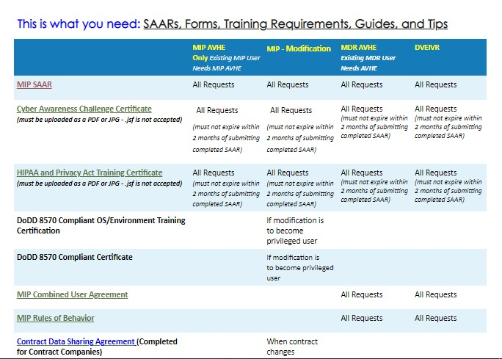
Figure A: Required documents for AVHE access
- Read the MIP Combined User Agreement and on the last page ensure Enclave = AWS and Authorization level = Standard. Date, sign, and save the document for upload to the MUG during a later step.
Note: Open the documents in Adobe Acrobat Reader to enable digital signing.

- Read the MIP Rules of Behavior and on Page 8 fill out your employee information, date, sign, and save the document for upload to the MUG during a later step.
Note: Open the documents in Adobe Acrobat Reader to enable digital signing.

- Complete the MIP SAAR for AVHE access. Date, sign, and save the document for upload to the MUG during a later step. For the sections identified below, complete as directed.
Note: Open the documents in Adobe Acrobat Reader to enable digital signing.
  - TYPE OF REQUEST: If you already have an AVHE account, then click on MODIFICATION. Otherwise, click on INITIAL.
  - SYSTEM NAME: This section is pre-populated and should not be changed
  - LOCATION: This section is pre-populated and should not be changed
  - Complete PART I with your personal information
  - PART II, 12. JUSTIFICATION FOR ACCESS: insert the roles and data source as indicated below and as shown in Figure 2
    - Project(s) and Role(s) Requestor needs access to:
MIPS_AWS_AVHE_GEN, MIPS_AWS_AVHE_SASEG
    - Data Sources Required: MDR SCE
  - Box 13. should be marked as AUTHORIZED as shown in Figure B.
  - Box 14. Should be marked as UNCLASSIFIED as shown in Figure B.
  - Check Box 15 and complete Box 15a if you are a Contractor.
  - Your supervisor should complete Boxes 16 – 19.
  - Boxes 20 – 29: Leave blank.
    - PART IV, Section 30: select Production

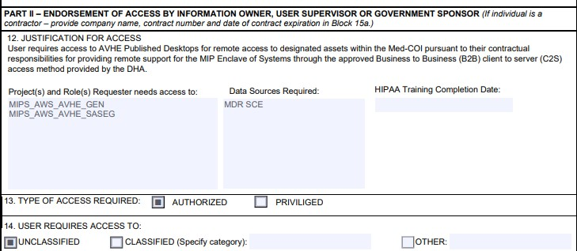
Figure B: Part II of MIP SAAR

  - PART IV, Section 31: Provide your PIV Number
    - Instructions on how to find your PIV Number can be found under SAAR Guides on the CarePoint website: https://carepoint.health.mil/sites/MIP/mugteam/SitePages/EIDS%20SAAR.aspx

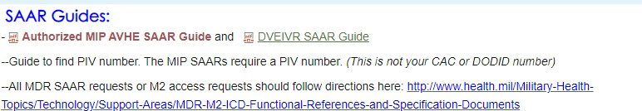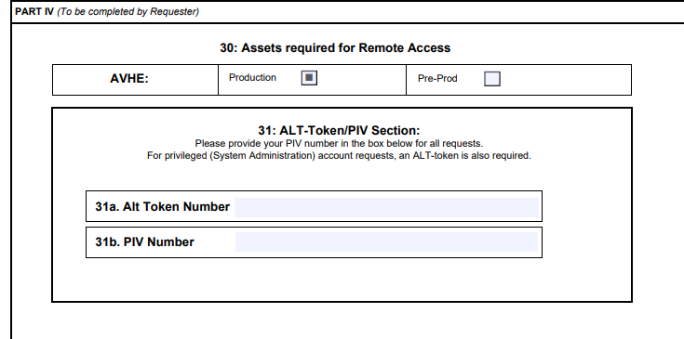

Figure C: How to find PIV number and enter it on the MIP SAAR

  - Review the agreements on Pages 3-5 and digitally sign the document acknowledging that you have read and agree to the policies and agreements.
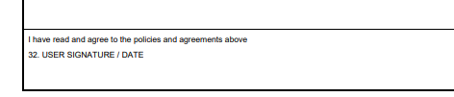
Figure D: MIP SAAR Digital Signature Block 32

- Proceed to Section 3 for instructions on submitting your documents to the MUG site for processing.

Section 3: Instructions for submitting your MDR SCE or AVHE forms for processing
- Log on to the MIP MUG site at https://carepoint.health.mil/sites/MIP/mugteam/SitePages/EIDS%20SAAR.aspx
Note: You will need your CAC card to logon

- On the MUG site, click the link in Step 1: B to start a new package as shown in Figure E.
Note: MDR is not yet integrated into the eSAAR process so do NOT follow the other options.

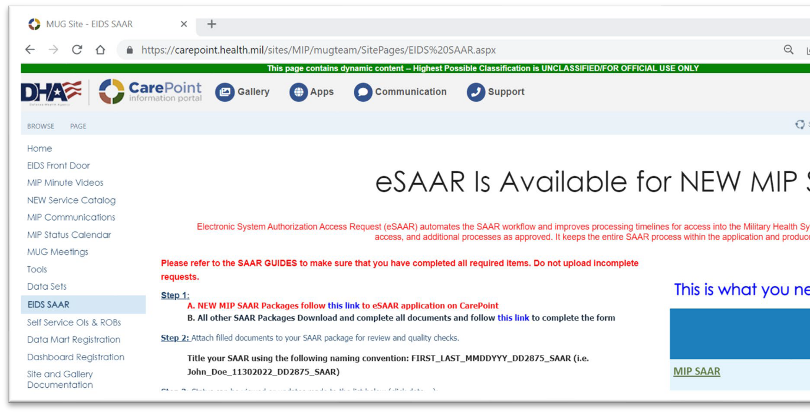 .
Figure E: MIP MUG Site

- Click on new item
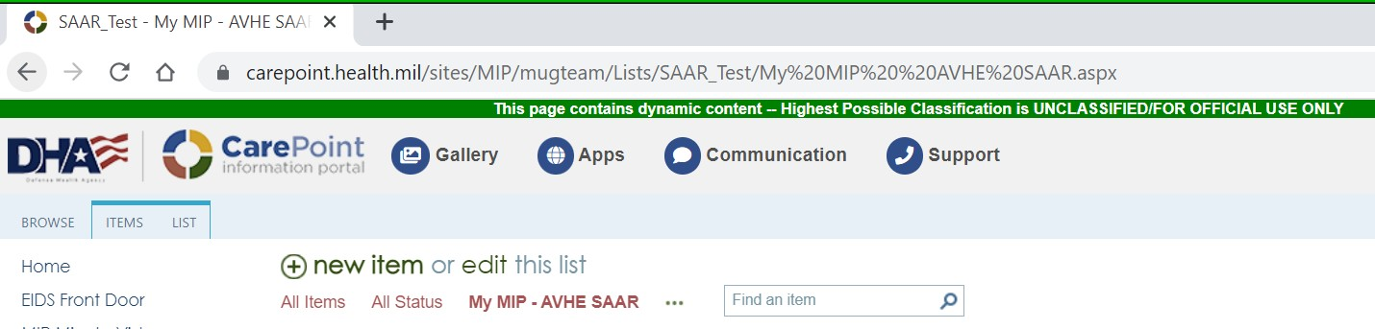

Figure F: Click on New Item

- Complete the MIP access request using the following instructions:
  - Enter your Personal Details where required.
  - System: Select MDR SCE or MDR AVHE
  - Personnel Type: Select Military, Civilian, or Contractor
  - Contract Company: Provide company name if the Requestor is a contractor
  - Data Sharing Agreement #: Provide the Data Sharing Agreement number (DSA #) if a contractor. An approved DSA is required in order to gain access to the MDR.
  - Organization: Select the Organization the Requestor is supporting which requires access to the MDR.
  - Project/Team: Select General Analyst
  - MIP Data Requested: enter MDR SCE.
  - Role Based Access Group: Select Advanced Data Analyst/Data Scientist - Non-
Privileged or Intermediate Data Analyst/General User – Non-Privileged
  - Reason Type: Select the category which best describes the Requestor’s role
  - Reason For Access: Insert MDR Access or MDR AVHE Access, depending on which form/access you are submitting for.
  - Licenses Limited MIP Tools: LEAVE UNCHECKED
  - Contract End Date: Provide the end date of the Requestor’s contract as cited on the AARF and SAAR
  - HIPAA Training Date: Provide the Requestor’s HIPAA & Privacy Act Training Certification date.
  - Cyber Security Training Date: Provide the Requestor’s IA/Cyber Awareness Training Certification date. The date on the certificate should match the date provided on the AARF and SAAR.

- Attach the Requestor’s completed documents by clicking on Attach Files at the top of the window The forms need to be attached individually, one at a time:
  - For MDR access, attach the completed (1) MDR AARF, (2) HIPAA & Privacy Act Training Certificate, and (3) Cyber Awareness Training Certificate
  - For AVHE access, attach the completed (1) MIP SAAR, (2) HIPAA & Privacy Act Training Certificate,
(3) Cyber Awareness Training Certificate, (4) signed MIP Combined User Agreement, and (5) signed MIP Rules of Behavior.

- After uploading all required documents, click Save as shown in Figure G.

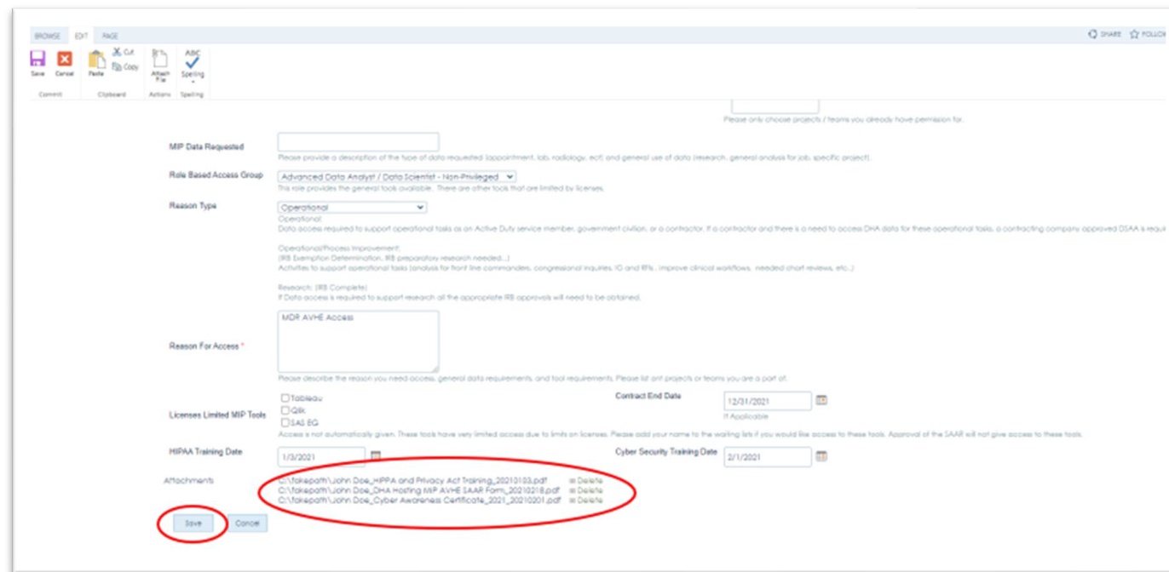
Figure G: Save SAAR Package

- Clicking Save will submit the access request to the MUG site for quality check/team review. If there are issues identified during the quality check, the MUG team will contact the Requestor via email to correct the issue(s).

Note: After initial submission, your access package “SAAR Calc Status” on the MUG site will state "Quality Check Not Complete, Normally SAAR Package is Incomplete". Do not be alarmed! As the package goes through the QC and validation process, the status will be updated and eventually result in “Completed – Submitted for Account Update”. If there are issues with the access package, you will be contacted separately.

- After approval of the AVHE access request, the MIP SAAR will be submitted to the AVHE Team for account creation. The requestor is typically copied on submission of forms to the AVHE Team.
Note: It takes an average of 17 consecutive days from request submission to account creation.

- The Requestor may view the status of their access request on the MUG site or attend the weekly MUG Open Forum where questions are welcome.

- Weekly Requester Open Forum Meeting: EIDS PMO hosts weekly meetings for any user/requester with SAAR questions Thursdays 0930-1000 EST.
Teams Link: Weekly Requester Open Forum Meeting Teams Link
Audio Dial In: +1 410-874-6747 Phone Conference ID: 157 444 592#

- Weekly RBAC/Access Meeting: Weekly meeting for any user/requester with MIP RBAC (Role Based Access Control) or related questions Wednesdays from 1500-1530 EST.
Teams Link: Weekly RBAC/Access Meeting Teams Link
Audio Dial In: +1 410-874-6747 Phone Conference ID: 692 863 914#

